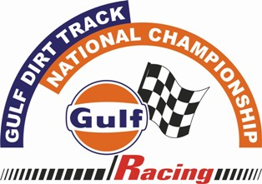

GULF DIRT TRACK NATIONAL CHAMPIONSHIP – 2012
A ROUND OF FMSCI CHAMPIONSHIP – MANGALORE Round 1

Press Release – 9th March 2012
The country’s best two-wheeler riders will be in action in the opening round of the Gulf Dirt Track National Championship 2012 – A round of FMSCI National Championship.
The popular Dirt Track National Championship Sponsored by Gulf Oil Corporation Ltd. for year 2012 kicks-off in Mangalore on March 17-18.
The event will be organized by Mumbai’s Sportscraft in association with Mangalore Motor Sports Association, and this will be the first of five rounds of this FMSCI Championship and will be held at the Fisheries College ground, Mangalore.
The total Points garnered by the riders over the five rounds of the Gulf Dirt Track National Championship will determine the National Champion - 2012.
Going by the popularity and competition over the Gulf Dirt Track National Championship from last couple of years, the Mangalore leg should be very competitive.
For those unfamiliar with the event, Dirt Track Racing is like an F1 race on motorcycles, where riders, after a mass start, speed around a serpentine track, on natural surface often slushy at places, looking to cross the finish first.
The race is an exercise in judicious maneuvering and good balance of the bike around the many sharp bends.
There will be a total of 6 classes in Championship round. The riders will fight for the honor as well as the total prize money of Rs.1,75,000/- along with the trophies which will be awarded. Whereas for the Champions, who garners maximum points in all five rounds a total Prize money of Rs.4,50,000/- & trophies will be awarded
For racing enthusiasts of Mangalore, a treat awaits. Besides some class riding they will also have the opportunity to see the latest dirt racing bikes from the TVS Motors, Yamaha and Honda stables.
Riders from all over India will be seen in action; Bangalore-based TVS riders Pramod Joshua, R. Natraj, who all excelled last season in the glamour class of the event Indian Expert Group A (foreign modified bikes), will be challenged by Harit Noah, Siddhant Nayak, Adnan Ahmed. Alen Sequeira, Javed Shaikh, Joaquim D’silva from Goa, Vineeth Kurup, Shamim Khan & Ganesh Lokhande from Nashik will join the fray
There will be stiff competition in Private Group B Class with riders like Jagjit Singh, Kannan Naidu , Kshitij Shukla from Mumbai, Kush Rao from Goa Maansingh Thakur from Nashik, Firoz Khan, Ismail Shaikh & Akash Satpute from Aurangabad, Suhail Ahmed & Wishvas S. D. from Bangalore.
Yuva Kumar and Abhijeet Shetty riders from TVS Team will be in action in Novice Class to challenge them will be Aditya Thakkar, Anish Nair from Nashik Kieth Dias, Wasim Shaikh & Irfan Killedar from Goa.
The popularity of dirt track racing over the last couple of years has prompted Gulf Oil to renew its commitment to the sport and offer riders a chance to show off their skills in a safe environment.
Sportscraft has already received 75 entries. A maximum of 25 entries per classification will be accepted.
Additionally there will be separate events for Karnataka & Mangalore riders The Standard entries closes on Wednesday 7 March 2012 & late entries closes on 13th March.
Entry forms and the Supplementary Regulation are available at the SPORTSCRAFT office, Chitrakut, 3rd Floor, Siri Road, Chowpatty Bandstand, Mumbai 400 006. And on site www.sportscraftindia.com
However all the entries will have to reach SPORTSCRAFT before Tuesday 13th March 2012.
About Gulf Oil Corporation Ltd.-
Gulf Oil Corporation Ltd is a Hinduja Group company and is a well established and leading Lubricant Company in India. The Iconic Gulf Brand is more than 100 years and is present in more than 90 countries word wide. Gulf Brand had been promoting Motorsports in India as well as internationally with the participation in the famous Le Mans 24hrs Endurance Race. Gulf Dirt Track races is being sponsored since last about 10 years.
Sponsored by Organised by In Association with Under the aegis of
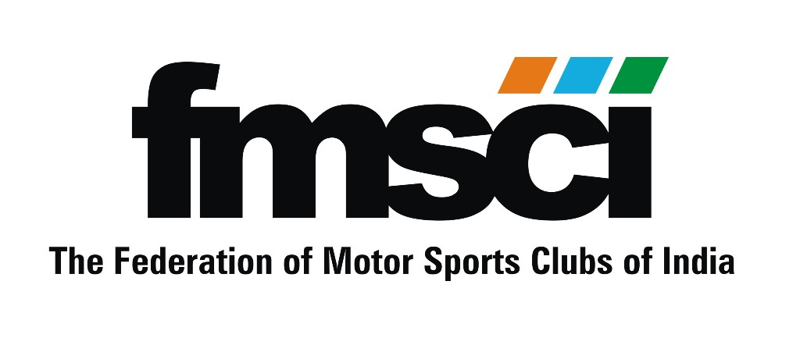 MANGALORE MOTOR
SPORTS ASSOCIATION

Sportscraft, Chitrakut, 3rd floor, Siri Road, Chowpatty Band-Stand, Mumbai – 400 006. Tel. 022 23677631, Email – sportscraft@gmail.com

